Brian Santana

Linux Administration

**Lab 2 The Grep Family**

1.Print all lines containing the string Street.

Grep will print every “Street” it finds in the datebook file.

Input: grep Street datebook

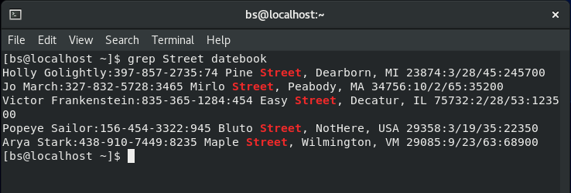

2.Print all lines where the person's first name starts with M.

In order to print this, you’ll need to add a ^ at the start to signify you want to search for M at the beginning of every line.

Input: grep ^M datebook

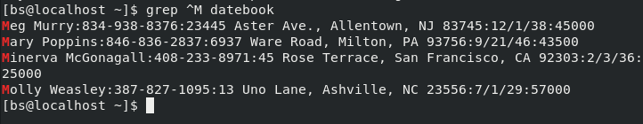

3.Print all lines ending in 000.

To get grep to print the last line you need to use a $ symbol to signify the end of the line.

Input: grep 000$ datebook

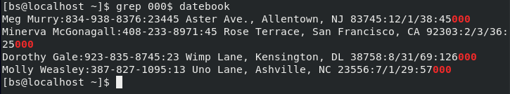

4.Print all lines that don't contain 408.

In order to exclude any lines with 408 you need to enter a -v.

Input: grep -v 408 datebook

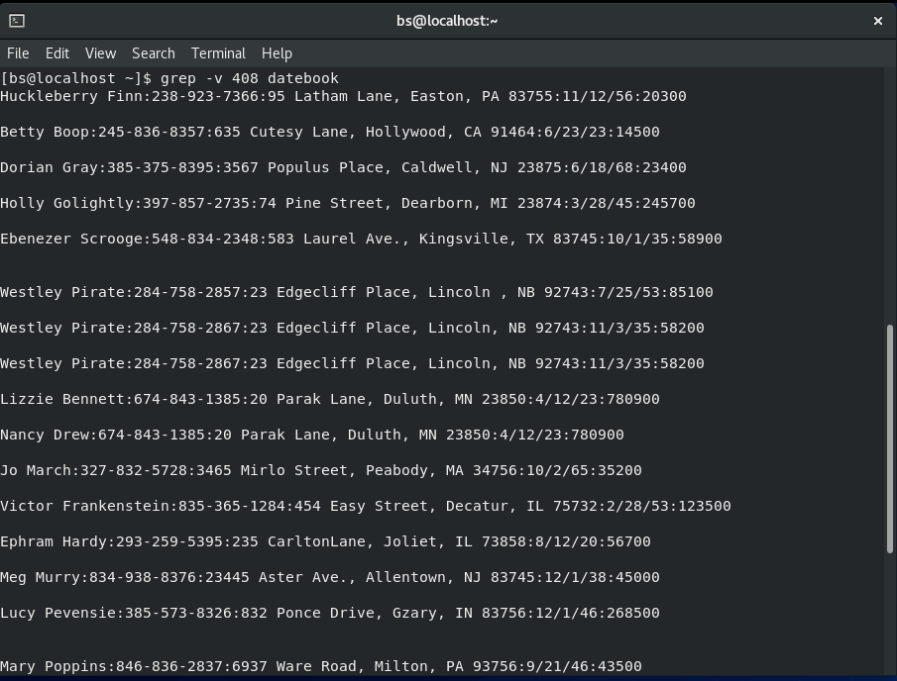

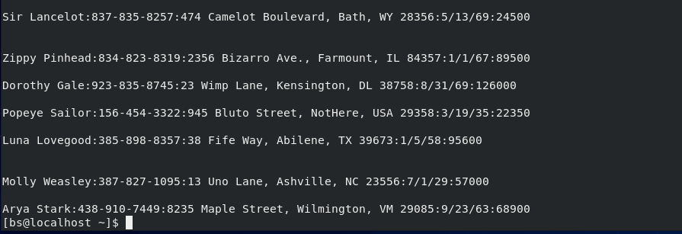

5.Print all lines where birthdays are in the year 1923.

By adding the /23 and the : at the end it helps specify where to look for giving you the exact result for the year if you only entered the /23 you would also get results for the day 23.

Input: grep /23: datebook

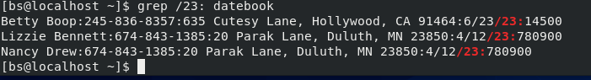

6.Print all lines where the phone number is in an area code that starts with an 8

It prints any number starting with :8 the other two numbers don’t matter due to the [0-9] allowing it to print out anything in between the specified digits.

Input: grep :8[0-9][0-9]- datebook

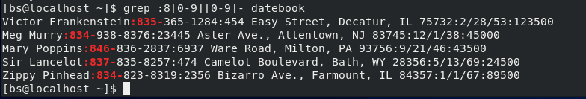

7.Print all lines containing an uppercase letter, followed by 5 lowercase letters, a comma, and one uppercase letter.

The [A-Z] is the first uppercase letter following that is the [a-z]\{5\}, to specify the undercase and number of letters then [A-Z] for the last uppercase letter.

Input: grep ‘[A-Z][a-z]\{5\}, [A-Z]’ datebook

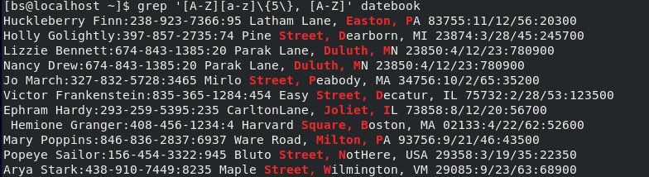

8.Print lines where the address begins with a two or three digit number (so this would be 12 main st or 123 main street but not 1234 main street).

The :[0-9] finds the first number then the [0-9]\{,2\} finds the two or three numbers and the [A-Z] finds the first letter of the address.

Input: grep ‘:[0-9][0-9]\{,2\} [A-Z]’ datebook

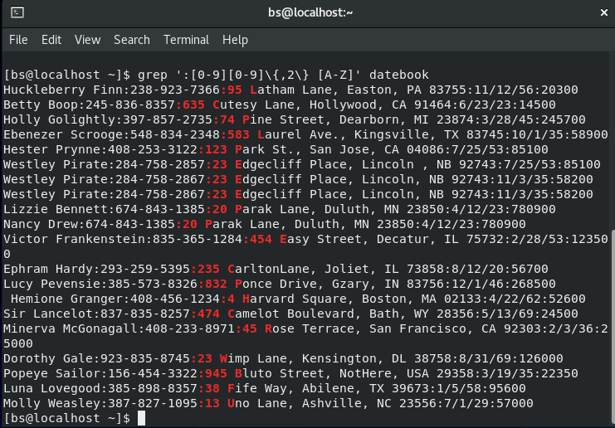

9.Print lines preceded by a line number where the person is from Massachusetts (or MA)

This command prints any line having MA with the line number accompanying it on the left side as seen in the image down below.

Input: grep -n MA datebook

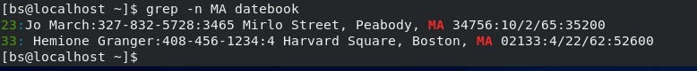

10.Print lines containing an address that doesn't include Street or St

Use -v to print all non matching lines and ‘\<St’ for anything that begins with St.

Input: grep -v ‘\<St’ datebook

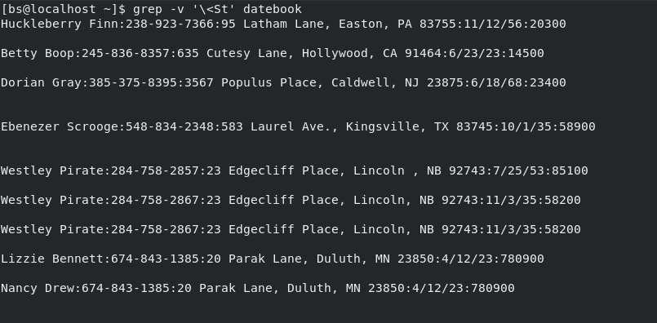

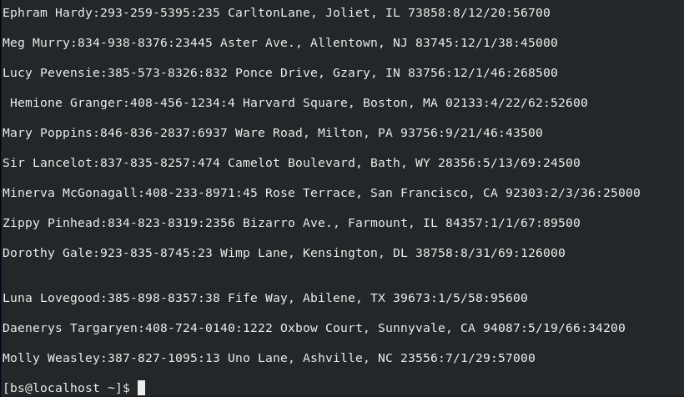

**Sources:** https://flylib.com/books/en/4.356.1.25/1/